**Università di Pisa**

**Distributed systems: paradigms and models**

Median Filter – Multi-core Implementation

*Antonio Mallia – 423458*

*me@antoniomallia.it*

**Abstract**

This software is the parallel implementation of a median filter over images. Realized in two different patterns and two implementations for each one. Automatic tests have been realized to obtain performance parameters. Results in terms of performance are in line with the expectation. Future improvements are possible.

1 Introduction 2

2 Design 2

2.1 Algorithm 2

2.2 Parallel Model 3

2.2.1 Map model 3

2.2.2 Farm model 5

3 Implementation 5

3.1 Sequential 5

3.2 Skandium Map 5

3.3 Java 8 Map 5

3.4 Skandium Farm 6

3.5 Java 8 Farm 6

3.6 Test Executor 6

4 Results 6

5 Conclusion 9

A Appendix 10

A.1 Usage 10

A.2 Documentation 11

A.3 Data collected and graphs 12

6 References 20

# Introduction

This report summarizes the work done to realize a software with the main purpose of reduction salt-and-pepper noise from images. It will be presented the phases of the algorithm identification, the parallel design choices, the implementation and the performance evaluation. Finally a conclusion with possible future enhancements is proposed.

In the appendix it is possible to examine a small documentation of the software usage to replicate the tests conducted.

# Design

The very first design stage has been the identification of the algorithm in charge of the execution of the median filter, with the aim of removing salt-and-pepper noise. The algorithm, in the first attempt, was engineered in a sequential form, to work on the whole matrix.

## Algorithm

The image, previously converted to a two dimensional matrix of integers, is scanned element-by-element, so pixel-by-pixel. For each element, some neighbours are collected. This stencil used is typically a square (also referred as window) where the analysed pixel represents the central one. The window can have several sizes; usually the side is an odd number. For this project a fixed window has been chosen of size 3x3.

The pixel values of the window are inserted in an array, which is then sorted and the median value is taken as a substitute for the analysed pixel. A new matrix is constituted with the new values to avoid interferences.

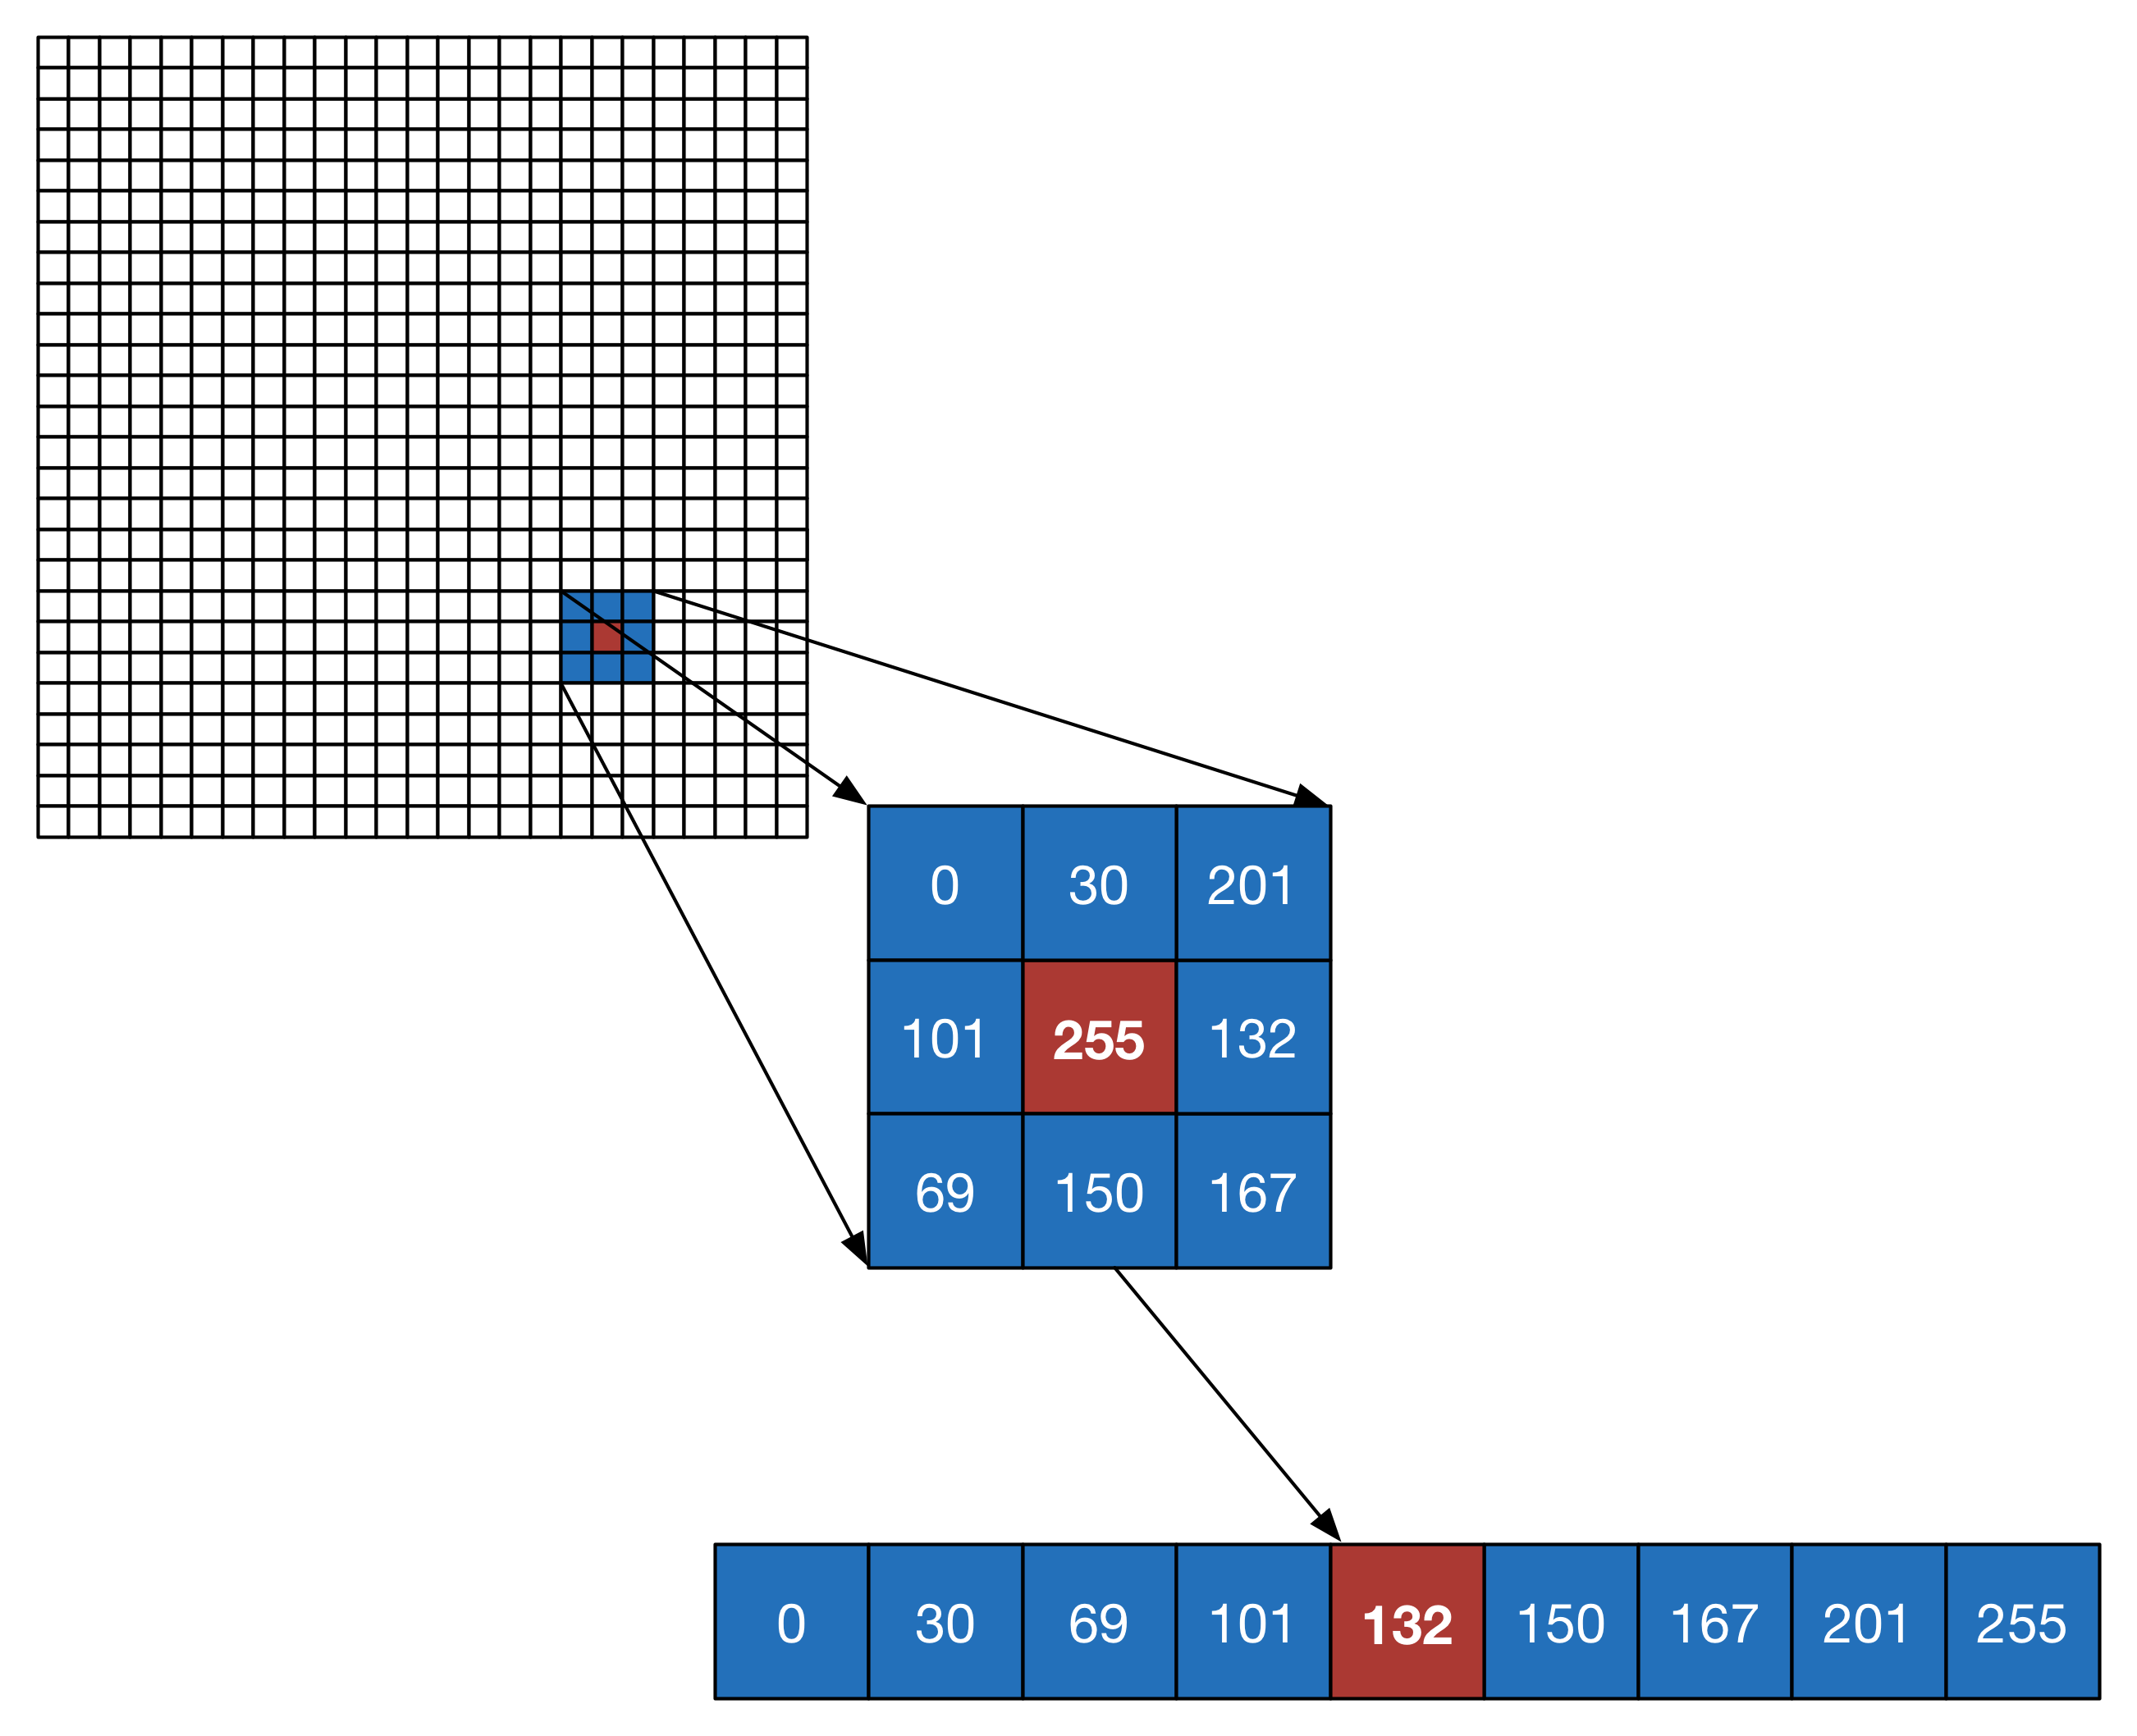

## Parallel Model

/**

* This method applies the median filter algorithm to the current matrix

*/

**public** **void** medianFilter() {

//**TODO** check again

**int**[][] denoisedMatrix = **new** **int**[getHeight()][getWidth()];

// The window side length (square window)

**int** windowSize = 3;

// window area

**int** window = windowSize * windowSize;

// padding from the center

**int** edge = windowSize / 2;

Color[] pixel = **new** Color[window];

// three arrays used for RGB colors

**int**[] r = **new** **int**[window];

**int**[] g = **new** **int**[window];

**int**[] b = **new** **int**[window];

// for each pixel in the matrix (border excluded)

**for** (**int** i = edge; i < **this**.getHeight() - edge; i++) {

**for** (**int** j = edge; j < **this**.getWidth()- edge; j++) {

// get all pixel values in the window

**for** (**int** k = 0; k < windowSize; k++) {

**for** (**int** l = 0; l < windowSize; l++) {

pixel[k * windowSize + l] = **new** Color(matrix[i + k

- edge][j + l - edge]);

}

}

// Decompose the colors in RGB

**for** (**int** k = 0; k < window; k++) {

r[k] = pixel[k].getRed();

g[k] = pixel[k].getGreen();

b[k] = pixel[k].getBlue();

}

// Sort

Arrays.*sort*(r);

Arrays.*sort*(g);

Arrays.*sort*(b);

// Get the median value and generate the color

denoisedMatrix[i][j] = **new** Color(r[window / 2], g[window / 2],

b[window / 2]).getRGB();

}

}

matrix = denoisedMatrix;

}

Starting from the sequential algorithm, two different parallel models have been individuated: the Map and the Farm models.

### Map model

The map model contemplates the split of the noisy image matrix in a number of chunks (sub-matrices). The split work is row based. This number depends on the available workers. Each of them is in charge of just one sub-matrix, all the workers operates in parallel.

When the workers terminate the execution of the median filter, the fractions of the matrix have to be merged back, producing the denoised version of the original image.

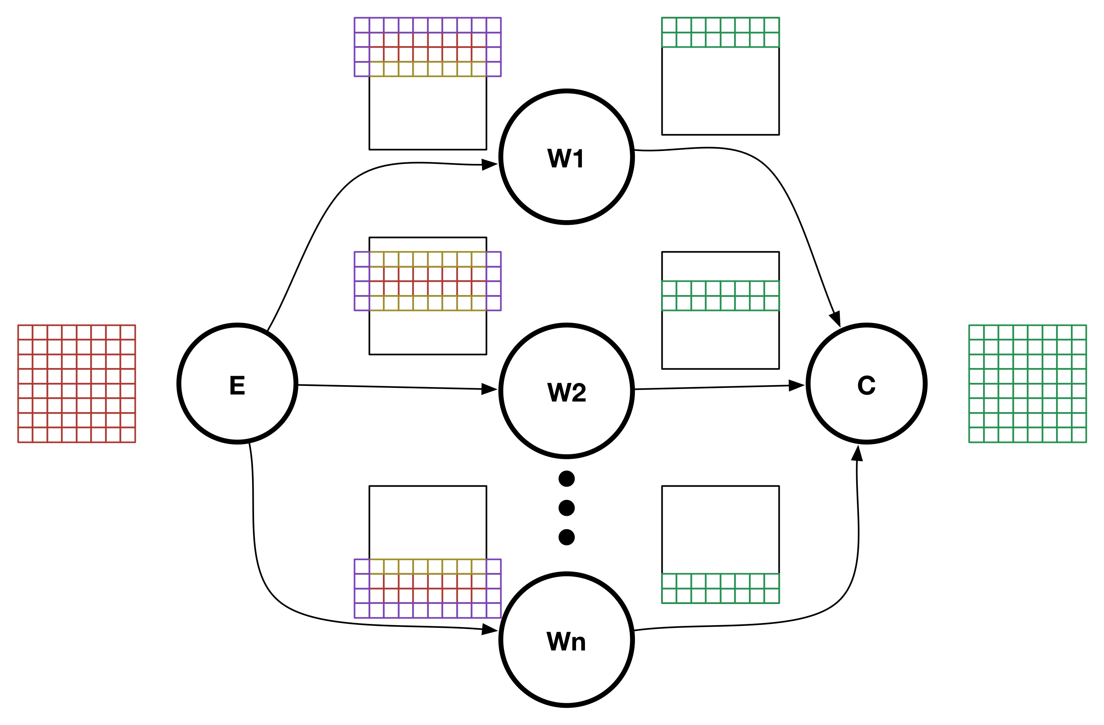

It is important to notice that the split of the matrix has to handle an overlap between chunks and generate an augmented matrix with dummy borders of replicated values. This lets the algorithm be able to compute also the edge pixels, obtaining same results of the sequential algorithm. In the merge phase only the computed pixels are actually merged and the augmented and overlapping ones are discarded.

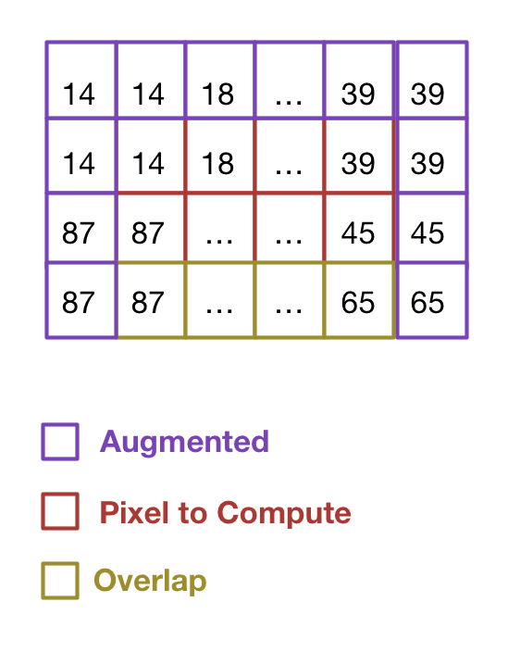

### Farm model

The Farm model, on the other side, is a coarse grain computation respect to the Map model. Indeed every worker is in charge of the computation for the whole matrix, but, considering a stream of several matrices, it is possible to spread them in parallel as many as the number of the available workers.

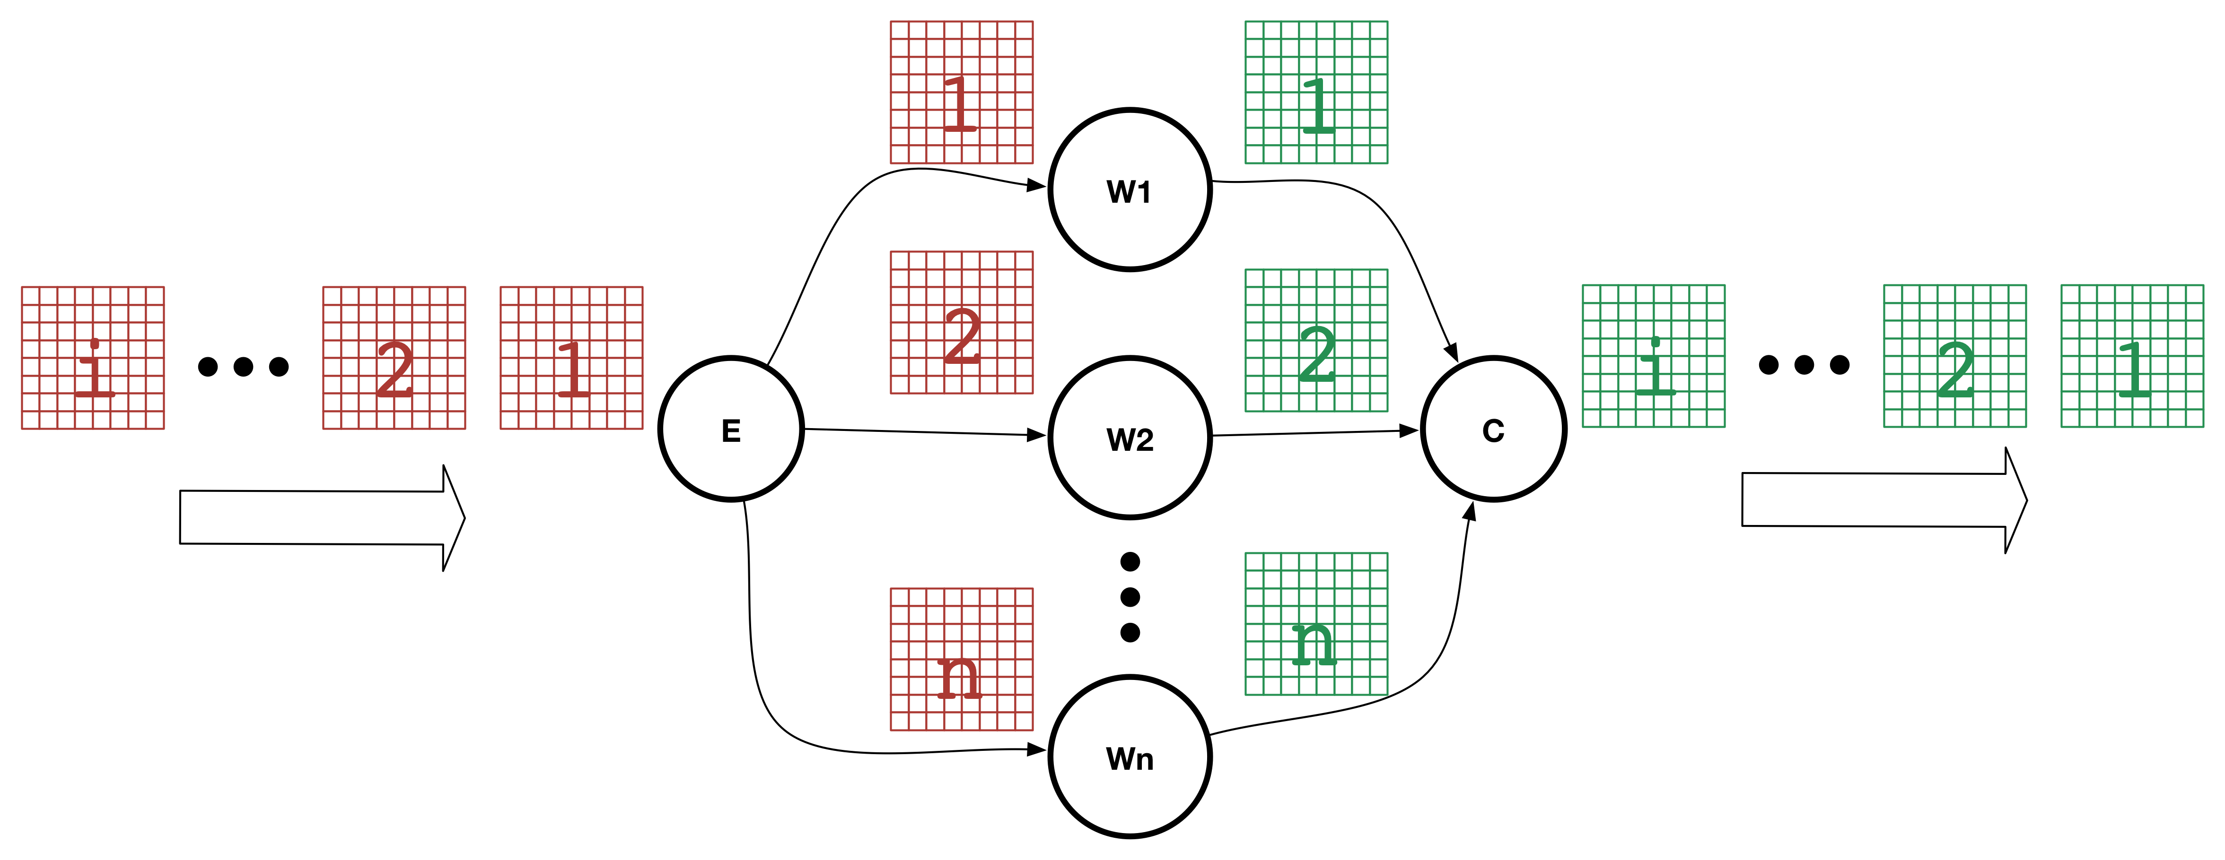

# Implementation

The software has been implemented using Java 8; in particular both the Map and the Farm patterns have a double implementation using Skandium and the new stream features of Java.

Skandium is a framework not supported anymore, even if it still works properly. It is interesting to notice how the new stream features allow obtaining similar results without the need of an external library.

## Sequential

The sequential implementations, which is very basic, is based on the augmentation of the original matrix with one containing a replication of the edge pixels, the execution of the median filter and then the removal of the not computed edge pixels.

This implementation has been used to compare the results with the parallel ones and to calculate performance parameters.

## Skandium Map

Skandium Map wraps the *Map* pattern provided by Skandium. It needs the implementations of the *Split*, *Merge* and *Execute* classes. The algorithms of these classes are shared with the ones used in the Java 8 Map.

## Java 8 Map

Java 8 Map uses the new stream features, in particular the map function. The input matrix is first split and then, using the Java Arrays class, it is converted to a parallel stream. The stream is mapped in parallel applying the filter algorithm and reduced to an array of sub-matrices. They are, finally, folded using the merge algorithm.

A dedicated *ForkJoinPool* is used instead of the “*ForkJoinPool.common.parallelism*”.

## Skandium Farm

In the Skandium Farm implementation no split nor merge is needed, indeed each worker execute the filter algorithm on the whole matrix. The execute class is the same used by the Skandium *Map* implementation.

## Java 8 Farm

In the Java 8 Farm implementation the array of matrices is converted to a parallel stream, each of them is mapped to the filter executor function and, finally, the computed stream saved back to an array.

## Test Executor

To execute automatic tests for each implementation, the class *Test* have to be extended defining the *compute()* and the *shutdown()* methods. The class *TestExec*, which contains a static main method, will instantiate them, execute tests and collect results.

When all the tests are finished, the generation of the excel results file is requested through the method *generate()* of the *ExcelGenerator* class.

# Results

Results are collected automatically in an Excel spreadsheet using the auxiliary Apache POI library. Then it is possible to easily manipulate the data to get some visually effective graphs or to export them.

For the performance evaluations, test are executed automatically on random generated matrices, results of each execution is collected in a Java bean and then all the “experiments” properly sorted and printed in the excel file.

The software has been tested on a dual AMD Opteron(tm) Processor 6176, with in total 24 cores and on an instance of AWS EC2 c4.8xlarge with 36 vCPUs. Complete data collected from tests executed and graphs obtained can be found in the appendix.

The Map skeleton service time expected is estimated using the formula

$$T_{s}\left(n\right)=T_{e}+\frac{T_{w}}{n}+T_{c}$$

where $T_{e},T_{w}, T_{c}$ are respectively time to split, compute and merge. This formula can be approximated to $\frac{T_{w}}{n}$ when the split and merge are significantly smaller then the compute time. From the data collected from the test with one single matrix, it is evident that this is true in the coarse grain computation and partially true for the fine grain with bigger matrices. In fact, the smallest size matrix reaches the asymptote (probably the time spent computing the serial fraction) at 4 cores, dramatically reducing the scalability and consequentially the efficiency. Predictably, scalability and efficiency of this model turn even better with bigger streams of matrices.

Another interesting aspect is that both the map implementations reached very close results in the single matrix test, the Java 8 stream implementation, on the other hand, goes a bit lower in the many-matrices test.

Macintosh HD:Users:antoniomallia:Downloads:skandiummap1.pdf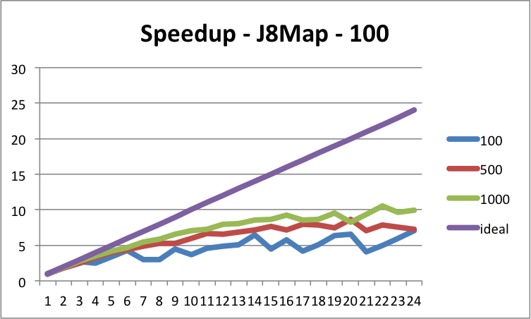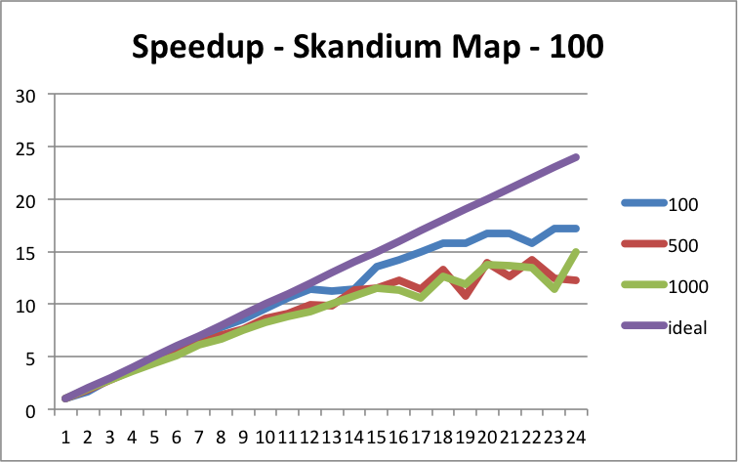Macintosh HD:Users:antoniomallia:Downloads:j8map1.pdf

Java 8 Map – 1 Matrix

Skandium Map – 1 Matrix

The Farm model is, obviously, totally useless with the single matrix stream and, so, only the many matrices test will be analysed.

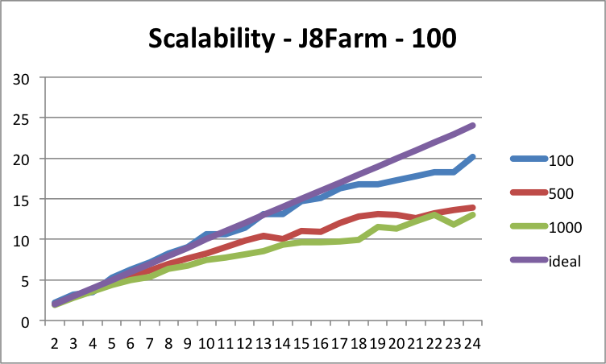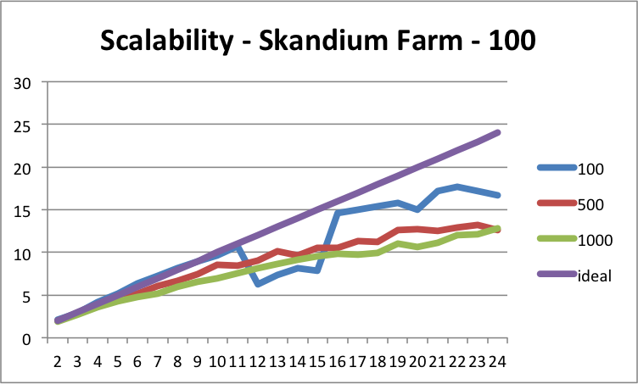The execution time of the Skandium Map and the Skandium Farm are comparable for both the 50 and 100 matrices tests, slightly better for the Java 8 stream one, leading to a very linear scalability and better efficiency.

++++++++++++

$$T_{s}\left(n\right)=max\{T_{e},\frac{T_{w}}{n},T_{c}\}$$

# Conclusion

Even if the software is just for didactic purpose, it actually works pretty well on real images. A comparison with a very well known image-processing library (OpenCV) has been done and the results are almost identical for quality obtained.

Compared to other libraries this software can scale on multi-core architectures and, taking the advantages of a farm pattern, be executed on an entire folder of images.

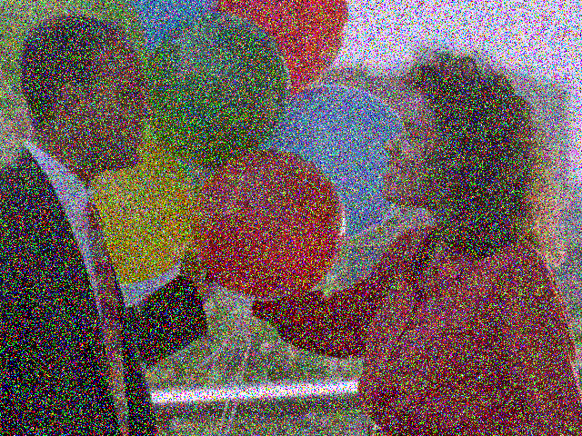

Original Image OpenCV MedianFilter

Some improvements for future releases are possible, both functional and performance ones.

1. Dynamic windows size: the software can be modified to accept as a parameter an extra integer (possibly odd) representing the window size. At the moment the side size is fixed, but increasing it a greater blur effect can be obtained, which can be useful depending on the noise level.
2. Noise identification: it can be introduces a two step pipeline, the first to detect the noisy pixels and the second to compute just this ones, probably obtaining a better output. The detect step should output a matrix of the same size of the original image, made of just Boolean values used to define if the correspondent pixel is noisy or not. To detect if a pixel is considered noisy, the algorithm is similar to the filter one, you get the median value from the window and compare with the actual value. If there is a huge difference then it is a noisy pixel and you mark as true the value at the correspondent coordinates.
3. Generalize the J8Map and J8Farm implementation: these skeletons have been realized to simplify the usage of the Java 8 stream features. It would be interesting to generalize them using interfaces for the Split, Merge, Execute class, to be able to reuse the skeleton, for example, to apply other kind of filter to images.

# Appendix

## Usage

The software can be compiled and packed automatically using Apache Ant.

Several targets are defined in the build.xml file, but the default is jar which package the software in a jar file ready to be run.

tar -xvzf medianFilter.tar.gz

cd medianFilter

ant

A jar file named MedianFilter.jar will be generated in the dist/ folder.

java –jar dist/MedianFilter.jar

The above command will show the following helper menu.

__ __ _ _ _____ _ _ _

| \/ | ___ __| (_) __ _ _ __ | ___(_) | |_ ___ _ __

| |\/| |/ _ \/ _` | |/ _` | '_ \| |_ | | | __/ _ \ '__|

| | | | __/ (_| | | (_| | | | | _| | | | || __/ |

|_| |_|\___|\__,_|_|\__,_|_| |_|_| |_|_|\__\___|_|

usage: MedianFilter -d <200,400,1000...> [-h] -s <1,10,50...> -t <4>

-d,--dim <200,400,1000...> matrix dimension in pixel

-h,--help print help message

-s,--stream <1,10,50...> number of matrices to test

-t,--threads <4> threads number

* -d, --dim : it allows defining the sizes of the (square) matrices generated for the tests. Several sizes can be provided using a comma separated format
* -s, --stream : it allows defining the number of matrices in the input stream. Several stream numbers can be provided using a comma-separated format.
* -t, --thread : it allows specifying the maximum number of threads to use.

The helper menu and the parsing of the parameters is done using Apache Commons Cli library.

When the test starts executing a log files is kept named execution.log in folder logs/ and, if run in foreground, the log is printed in the console. The log is generated using the Apache Log4J2 library. A short example of the output is show below:

2015-08-27 23:03:01,982 INFO - Performance Test started

2015-08-27 23:03:01,984 INFO - Executing Test ==> Type: Sequential Thread number: 0 Matrices number: 1 Matrix size: 100 x 100

2015-08-27 23:03:02,512 INFO - Execution time: 21 ms

2015-08-27 23:03:02,515 INFO - Executing Test ==> Type: Sequential Thread number: 0 Matrices number: 1 Matrix size: 100 x 100

2015-08-27 23:03:02,528 INFO - Execution time: 8 ms

2015-08-27 23:03:02,533 INFO - Executing Test ==> Type: Skandium-MapReduce Thread number: 1 Matrices number: 1 Matrix size: 100 x 100

2015-08-27 23:03:02,553 INFO - Execution time: 18 ms

2015-08-27 23:03:02,554 INFO - Executing Test ==> Type: Skandium-MapReduce Thread number: 1 Matrices number: 1 Matrix size: 100 x 100

2015-08-27 23:03:02,578 INFO - Execution time: 22 ms

2015-08-27 23:03:02,580 INFO - Executing Test ==> Type: Skandium-Farm Thread number: 1 Matrices number: 1 Matrix size: 100 x 100

2015-08-27 23:03:02,586 INFO - Execution time: 5 ms

2015-08-27 23:03:02,586 INFO - Executing Test ==> Type: Skandium-Farm Thread number: 1 Matrices number: 1 Matrix size: 100 x 100

2015-08-27 23:03:02,593 INFO - Execution time: 4 ms

2015-08-27 23:03:02,595 INFO - Executing Test ==> Type: J8-MapReduce Thread number: 1 Matrices number: 1 Matrix size: 100 x 100

2015-08-27 23:03:02,608 INFO - Execution time: 12 ms

2015-08-27 23:03:02,608 INFO - Executing Test ==> Type: J8-MapReduce Thread number: 1 Matrices number: 1 Matrix size: 100 x 100

2015-08-27 23:03:02,622 INFO - Execution time: 8 ms

2015-08-27 23:03:02,625 INFO - Executing Test ==> Type: J8-Farm Thread number: 1 Matrices number: 1 Matrix size: 100 x 100

2015-08-27 23:03:02,634 INFO - Execution time: 7 ms

2015-08-27 23:03:02,634 INFO - Executing Test ==> Type: J8-Farm Thread number: 1 Matrices number: 1 Matrix size: 100 x 100

2015-08-27 23:03:02,641 INFO - Execution time: 6 ms

## Documentation

Javadoc documentation can be generated using the command

ant javadoc

The documentation will be placed under the folder “/doc”

## Macintosh HD:Users:antoniomallia:Downloads:SkandiumMapData.pdfData collected and graphs

**Skandium Map**

Macintosh HD:Users:antoniomallia:Downloads:SkandiumMap-Graph.pdf

**Macintosh HD:Users:antoniomallia:Downloads:J8MapData.pdfJava 8 Map**

**Macintosh HD:Users:antoniomallia:Downloads:j8mapgraph.pdf**

**Macintosh HD:Users:antoniomallia:Downloads:SkandiumFarmData.pdfSkandium Farm**

**Macintosh HD:Users:antoniomallia:Downloads:SkankiumFarm Graph.pdf**

**Macintosh HD:Users:antoniomallia:Downloads:J8FarmData.pdfJava 8 Farm**

**Macintosh HD:Users:antoniomallia:Downloads:J8FarmGraph.pdf**

# References

1. M. Aldinucci, C. Spampinato, M. Drocco, M. Torquati, and S. Palazzo, “A Parallel Edge Preserving Algorithm for Salt and Pepper Image Denoising,” in Proc of 2nd Intl. Conference on Image Processing Theory Tools and Applications (IPTA), Istambul, Turkey, 2012, pp. 97-102.
2. Skandium Documentation - http://backus.di.unipi.it/~marcod/SkandiumClone/skandium.niclabs.cl/documentation/index.html
3. Richard Warburton, Java 8 Lambdas, April 7, 2014, O'Reilly Media
4. Raoul-Gabriel Urma, Mario Fusco, and Alan Mycroft, Java 8 in Action, August 2014, Manning Publications
5. Steve Holzner, Ant: The Definitive Guide, 2nd Edition, April 23, 2005, O'Reilly Media
6. Apache POI - https://poi.apache.org/
7. Project Lombok - https://projectlombok.org/features/
8. CLI - Apache Commons - https://commons.apache.org/proper/commons-cli/
9. Apache Log4j 2 - http://logging.apache.org/log4j/2.x/